**Issued: [●] June 14th 2014**

**For Immediate Release**

**COLOUR YOUR COUNTY FOR HISTORIC COUNTY FLAGS DAY**

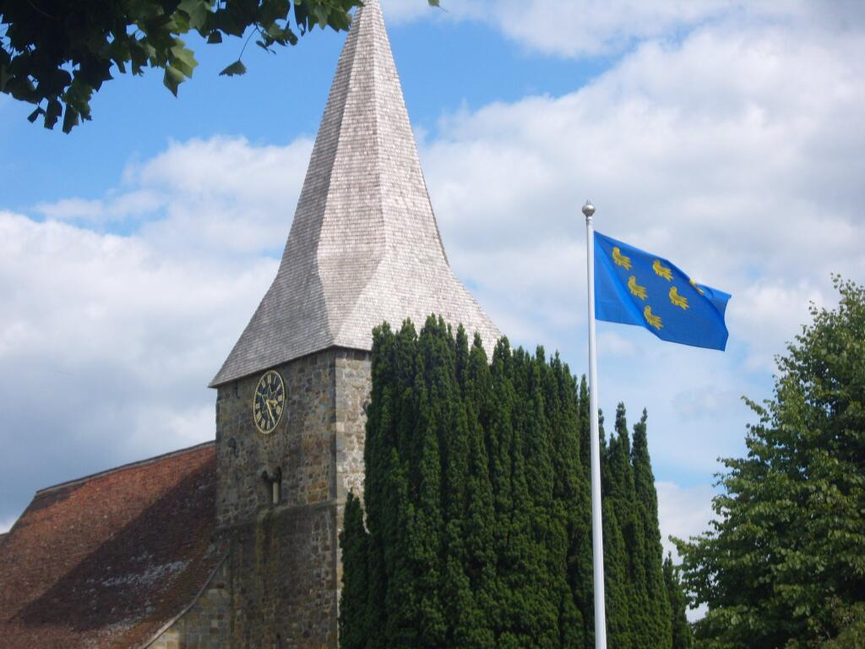

The flag of the county of Sussex flies proudly in the village of Burwash, Sussex.

A national day of celebration has been announced by the Association of British Counties to encourage the population of Great Britain to display their county flag in honour of their historic county. The inaugural annual Historic County Flags Day will be on Wednesday 23rd July 2014. The event is supported by the UK's flag charity the Flag Institute, which maintains the national registry of county flags, and The Department for Communities & Local Government.

The aim of Historic County Flags Day is to get as many county flags flying across Great Britain as possible on one day, Wednesday 23rd July 2014, to mark the nation's historic counties. The British public are being urged to use social media and the hashtag #CountyFlagsDay on, and leading up to July 23rd to display their county identity.

County flags are a relatively recent phenomenon, with the vast majority of them being adopted in the past twelve years; the most popular however, is the white cross on black of Cornwall, which is much older and which Cornishmen contend is most certainly a national flag. This has become an iconic symbol of Cornwall and the Cornish – it is hard to miss on a car bumper driving down any British motorway.

Another popular county flag is the white rose on blue of Yorkshire, which was a fairly common sight in the Olympic crowds at London 2012, with the likes of Yorkshire's Jessica Ennis and the Brownlee brothers competing in the games. However, the recent emergence of county flags has to be credited to the adoption of the county flag of Devon, adopted in 2002. This inspired other counties to adopt their own official banner, with competitions taking place in shires such as Lincolnshire, Dorset and Orkney, all enthused by the acceptance of Devon's flag. July 23rd 2014 marks the twelfth anniversary of the Devon county flag, since which time twenty six further counties have registered official flags.

Peter Boyce, Chairman of the Association of British Counties says:  
"For centuries the 92 historic counties of the UK have formed the familiar geographical background to our national life.  People’s affinity for their county goes deep. The historic county provides a living link to past generations who trod the same ground and nurtured the same loyalties as today’s Britons.

The historic counties speak to us of the wonderful diversity of the UK, each possessing its own distinctive history, landscapes, traditions, dialects and building styles. Their long unbroken histories have made them the natural basis for cultural, social and sporting organisations.

This common inheritance is something which we should value and cherish. Displaying your county’s flag on 23rd July (and every other day too!) is a perfect way to do.”

Charles Ashburner, Chief Executive of the Flag Institute says:

*"In Great Britain, our most enduring tribal groupings are perhaps our traditional counties. Rich in history, yet inclusive of all of parts of society, these areas have survived modern administrative boundary changes and - due in no small part to the efforts of the Association of British Counties - are enjoying an impressive resurgence.*

*As county identities have flourished so the need for symbols combining both old and new has increased. Flags have been the ultimate symbols of identity throughout history, and they remain so today. Individuals of wildly differing age, sex, religion, or political creed can hold aloft the same flag – and suddenly they are part of the same tribe.*

*As the UK's national flag charity, the Flag Institute has worked hard to support those wanting to establish their own county flags. We are therefore delighted to endorse 'Historic County Flags Day'."*

 You are invited to participate in this celebration and to 'Colour Your County!', whether or not your county has a flag.  Full details can be found at: countyflagsday.abcounties.com

 Contact: Brady Ells, Historic County Flags Day Coordinator at **countyflagsday@abcounties.com**

#CountyFlagsDay

